BUS Matrix

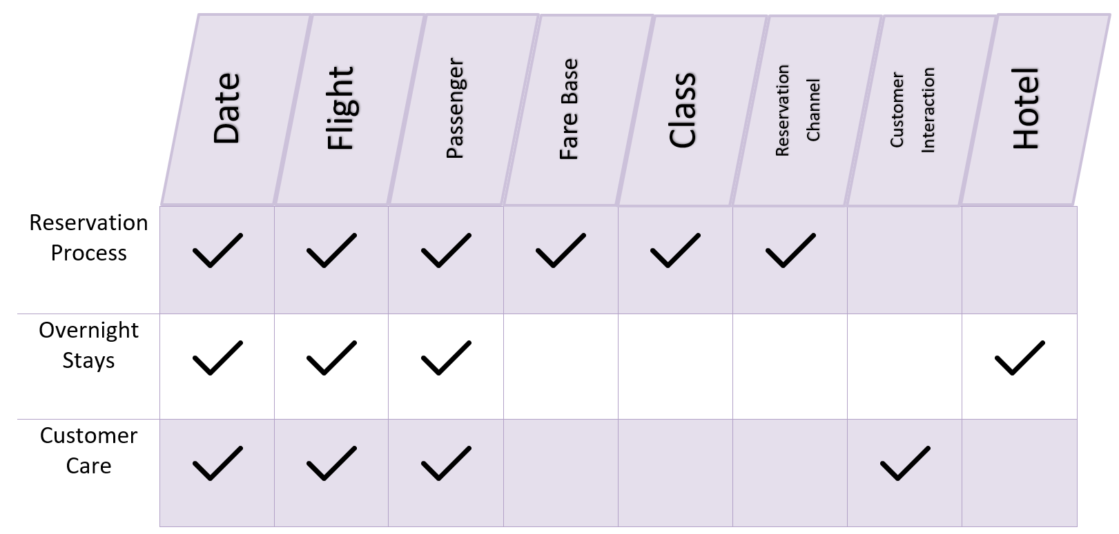

Logical Model

**Schema Used** 🡪 GALAXY SCHEMA – as the business has more than one business processes.

**Business** **Process** 🡪 Flight Activity

**Graduality** 🡪 Reservation No 🡪 Atomic

**Dimensions** 🡪

* + Date: represent date, day, week, month, quarter and year
  + Passenger: represents information for each passenger, Id, first name, last name, nationality, birthdate, address, phone number and status.
  + Flight: represent information of the flights, Flight number, arrival and departure airports and time and also miles.
  + Fare Base: represents the fair amount to be paid for each class, fare base code, amount, special offers and tax on this fair.
  + Customer Interaction: represents the type of interaction customer made, either comment, complaint or inquiry, includes the interaction code and type.
  + Reservation Channel: represents the channels that can be booked at, reservation channel code and type.
  + Class: represents the class a customer purchased on a flight and the class flown.
  + Hotel: represents information about the hotels that the passengers spend night in.

**Facts** 🡪

* + - * Customer Care: process that can measure the Problem severity and feedback of passengers.
      * Reservation: Process to track the profits, reservation related details like seat number, earned miles and redeemed miles.
      * Overnight Stay: process that counts the nights spent at a hotel for which flight, passenger and date.

